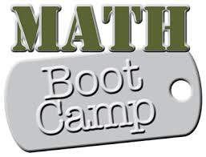
January 20, 2015

Dear Parents/Guardians,
Tiger Academy will be holding its first annual Math Boot Camp beginning Wednesday, January 21, 2015. Students will receive 3 weeks of tutoring or enrichment instruction on our new Florida Math Standards. Tutorial groups will be kept small so that your child can receive instruction based on their individual math needs, therefore, space is limited. Only students that receive an invitation can attend. Please only sign up if you can commit your child to attending all 18 days of instruction. Send a snack and small drink with your child daily. Thank you!
Who: Students needing tutorial or enrichment instruction on Florida Math Standards
What: Math Boot Camp; Session 1
When: January 21st to February 17th; Monday thru Thursday from 3:30 pm to 4:45 pm
Where: Room 308, Ms. Tookes classroom

My child WILL attend Math Boot Camp ___ My child WILL NOT attend Math Boot Camp ___
Parent Signature __________________________

Student Name ____________________________

Teacher Name ____________________________

Please indicate whether your child attends one of the two programs listed below:
- My child attends 21st Century _____
- My child attends Before and After School Care _____
- My child does NOT attend either program ______

