Dear Parents/Guardians of Robotics Students:
We are quickly approaching the Qualification tournament for the First Lego League Robotics team! Here is all of the information you need to know about our upcoming event:

Who: Robotics Club Students
What: Wisdom Warrior Challenge FLL Qualifier
The Wisdom Warrior Challenge is the first Northeast Florida Qualifier of the 2013 Trash Trek season. Located in the Mandarin area of Jacksonville, this is home to the very first FLL qualifier at a public school in the Northeast Florida region.
When: December 13, 2015
Start Time: 8:00 AM End Time: 4:00 PM
Where: Loretto Elementary School - Multipurpose Room
3900 Loretto Road
Jacksonville, FL 32258
Requirements: Please complete the registration form online http://my.usfirst.org/stims/Login.aspx or send in the attached registration sheet ASAP. Students that do not have a completed form will not be able to participate.

It is very important that your scholar make it to this event! This will be the only qualifying activity that students will be able to attend. If you are in need of transportation, or are willing to take students that need transportation to this event please contact Ms. Fuller at 904-309-6840 ex. 214 no later than Thursday, 12/09/15. (Carpool will meet and drop off at Tiger Academy).
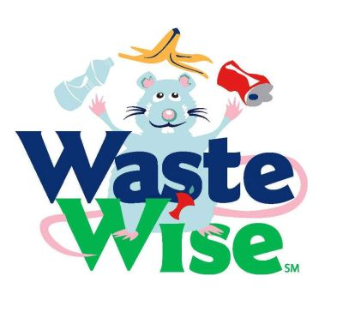
Sincerely,
Ms. Fuller and Mrs. Olson

