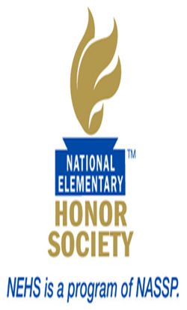

NEHS Information

The National Elementary Honor Society chapter of Tiger Academy Elementary is a duly chartered and affiliated chapter of this prestigious national organization. Membership is open to those students who meet the required standards in two areas of initial evaluation: scholarship (academic achievement) and responsibility. General standards for selection are established by the national office of NEHS and have been revised to meet the needs of our school and fall within our strategic goals.

Students are selected to be members of NEHS based on academic and behavioral components. This group awards the honor of membership to qualified students on behalf of the faculty of the school during each school year. Our NEHS chapter will conduct its selection process in August of each year.

Students in the fourth and fifth grade are eligible for membership. For the scholarship criterion, a student must have a cumulative grade point average of 3.5 or better on a 4.0 scale and a 3.0 or better in Conduct on a 4.0 scale. Also, those students who have been recognized based on their FSA scores in Reading and Math of two level 4 scores, or a level 5 score.

Following notification, a formal induction ceremony is held at the school to recognize all newly selected members. Once inducted, new members are required to maintain the same level of performance (or better) in all of the criteria that led to their selection. This obligation includes regular attendance at chapter meetings held during the school year, and participation in chapter service projects and activities.

Students or parents who have questions regarding the selection process or membership obligations can contact the chapter adviser, Ms. Tardif, in room 112, or by phone at (904) 309-6840 ex. 207.

You must maintain a 3.5 or better GPA in your academics and a B or better in conduct to maintain your membership. If your grades fall below a 3.5 you will be placed on probation for a 9 week marking period until your grades are pulled up or you will no longer be a member in good standing.

We will have monthly meetings and will be a service based organization participating in community service projects.

All members shall regularly participate in meetings and projects planned for the chapter.

AGREEMENT
Student –Please read.
I agree to abide by the standards and guidelines of the chapter and to fulfill all of my membership obligations to the best of my ability.

Student Signature______________________________________Date____________

Parent – Please read.
I/we have read the information provided by my son/daughter on this form and can verify that it is true, accurate, and complete.

Parent Signature_______________________________________Date____________

Please check this box and sign below if you are NOT interested in being considered as a candidate for NEHS membership at this time. Students will be eligible for consideration in the future as long as they continue to meet the eligibility requirements for candidacy.

Student Signature_____________________________________Date_____________

Parent Signature______________________________________Date_____________

TIGER ELEMENTARY CHAPTER OF THE NATIONAL ELEMENTARY HONOR SOCIETY INFORMATION SHEET
Directions: Please complete all sections of this form. Print all information and submit by the published deadline.
Student Information:
Student Name:________________________________________________________

Parent/Guardian Name(s):_______________________________________________

Parent Contact information:
Phone:_______________________________________________________________

Email:_______________________________________________________________

Mailing Address:
Street Address:_____________________________________________________

City/State/Zip:_____________________________________________________

