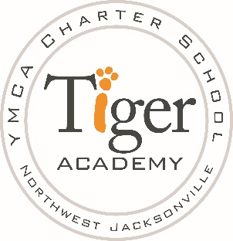

September 1, 2016

Dear Parent/Guardian,

Tiger Academy is engaged in an ongoing continuous improvement process, of which all stakeholders are an integral part. Tiger Academy is using the AdvancED Parent Survey as a means to elicit your opinions to help target areas for the school system to improve and areas to continue to be effective. The five sections on the survey represent the five AdvancED Standards for Quality School Systems and provide a means for learning about parent expectations of a high-quality school system.

Soon you will receive information on how to access the survey. Your cooperation and support in completing the parent survey will be greatly appreciated.

Charles McWhite
Principal

