TIGER ACADEMY CHARTER SCHOOL
Building Tomorrow’s Leaders
STRATEGIC PLAN: 2016-2020

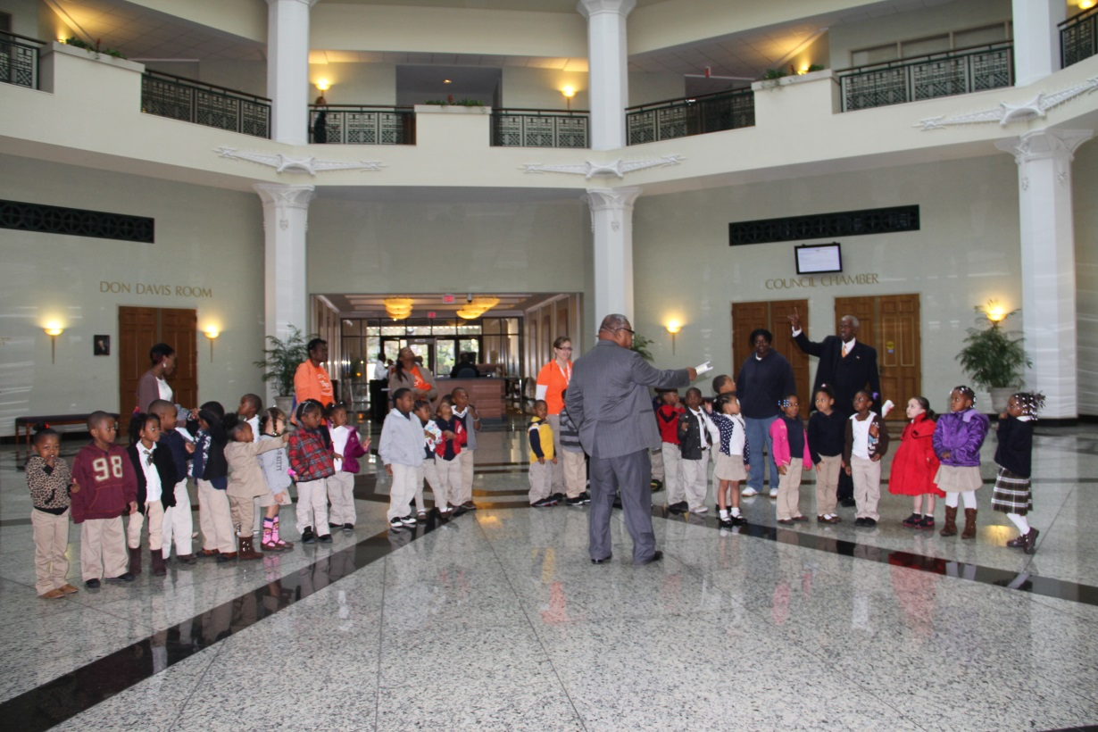

Table of Contents

Our Philosophy
Our Mission
Our Vision
Letter from the Principal
Strategic Planning Committee Members and Tiger Academy Board Members
Academic Excellence
Family and Community Engagement
Exemplary Staff
Effective and Efficient Operations

Philosophy
At Tiger Academy, a free public school, we believe school should be more than a place to learn reading, writing and arithmetic. We approach the education of each child with a commitment to helping him or her grow in spirit, mind and body.
Tiger Academy focuses on rigorous academic standards, character development, personal and social responsibility and strong family involvement, while providing each child with a structured and nurturing learning environment. The learner-centered culture includes a 7 ½ hour school day and a 200-day school year, with before and afterschool care available.
Through a unique partnership with the Johnson Family YMCA, Tiger Academy’s students enjoy enrichment opportunities and benefit from family support services. Tiger Academy provides, not only a high-quality education for the children growing up in northwest Jacksonville, but the encouragement and support they need to succeed.
Our Mission
To provide the children of the North side a structured and nurturing learning environment that is focused on rigorous academic standards, character development, self-discipline, personal and social responsibility and family involvement.
Our Vision
To build a 21st Century educational environment that inspires each child to be self-sufficient, responsible, cooperative and caring members of our community.

Dear Friends,
I am honored to present the Tiger Academy 2013-2019 Strategic Plan. The ideas presented in the following pages are the culmination of nearly a year of dialogue, deliberations, and planning that included educators, staff, board members, parents, students, and other members of the Tiger Academy community. During the development of our strategic plan, we focused on three fundamental questions:
1. What is most important for our scholars to know and be able to do?
2. How can we best develop these outcomes?
3. How will we know when we are successful?
The process of devising a strategic plan allowed the Tiger Academy community the opportunity to reflect on the successes of the past six years, as well as to focus on the opportunities for improvement. In some cases, this will mean staying the course to sustain successes already in place. In other instances, we are defining new areas of focus and charting new courses of action.
Our strategic plan will set the path for Tiger Academy going forward, focusing on a consistent, aggressive and strategic structure of excellence for our scholars. Our objectives, initiatives and action plans will be measured for effectiveness and ultimately lead to improved student achievement.
We believe that this Strategic Plan represents the promise of what can be accomplished over the next five years. We have high expectations for our scholars’ performance and know that this Plan is the guide to help ensure the success of all of our students. We recognize that the Tiger Academy community’s ongoing support is critical to our success. We invite you to continue to partner with us as we strive to achieve the ambitious goals of this Strategic Plan.
Educationally Yours,

Charles McWhite
Principal

Strategic Planning Committee Members and Tiger Academy
Board of Directors

Jean Aikens
Brooke Cobbin
Irvin (Pedro) Cohen
Tonia Fuller
Susan Golden
Leanne Gorman
Susan Harper
Rodina Hughes
Charles McWhite
Pamela Thorbs

Board of Directors
John J. Allen
Gregory L. Atwater
Edward L. Baker, II
John D. Baker, II
Thompson S. Baker, II
Shelly Boynton
Peggy Bryan
Nathaniel Glover, Jr.
John Lock
The Honorable Mia Jones
Eric Mann
Josh Martino
Cleve Warren
Founding Board Members
Ambassador John Rood and President John Delaney
Our School Goals
Academic Excellence
Family and Community Engagement
Exemplary Staff
Effective and Efficient Operations

By the year 2020 Tiger Academy will reach the following goals:

- Academic Excellence
  - 85 % of students in grades 3-5 will be proficient in reading and math
  - 85% of students in grades 3-5 will show a 20% growth between the Fall and Spring benchmark assessment
  - A minimum of 95% of students will be promoted each school year
  - A minimum of 90% of students in Pre-K will be ready for Kindergarten per the Florida Kindergarten Readiness Screening (FLKRS)
  - 80% of exiting 5th graders will be strategically placed at a middle school that best fits the needs of the scholar.
  - All students will belong to an extracurricular program at school
- Family and Community Engagement
  - 85% of parents will complete the required number of volunteer hours.
  - 100% of parents will attend at least two face-to-face parent-teacher conferences.
  - 55% of parents will complete the parent survey.
  - 90% of students who enter by grade 2 will remain at TA for four years.
  - 75% of parents will be PTA members.
- Exemplary Staff
  - 100% of teachers and administration will be effective or highly effective as measured by the Florida Consortium of Public Charter Schools (FCPCS) Evaluation System
  - We will build a retention plan so that 80% of effective or highly effective certificated staff will return each year.
  - 95% of parents feel that there is an atmosphere of respect and trust that exists between parents and school personnel.
  - 100% of all staff will participate in professional development that is aligned with school goals.
- Effective and Efficient Operations
  - We will maintain AdvancED Accreditation.
  - We will be in compliance with all fiscal policies.

GOAL ONE:
ACADEMIC EXCELLENCE
Every student will be academically successful and prepared for middle school.

ACADEMIC EXCELLENCE STRATEGIES:
- Students will receive a minimum of 2.0 hours of literacy instruction daily. This is a state mandate and is outlined in the teacher expectations documents and school-wide non-negotiables list. This is the minimum number of instructional hours required for literacy instruction, however many students receive additional instruction through our intervention and enrichment programs.
Measures:
- Teachers will maintain lesson plans documenting 2.0 hours of literacy instruction. Lesson plans are submitted on a weekly basis and reviewed by administrators and coaches for accuracy and rigor.
- Student work samples will support learning. Teachers will maintain student portfolios and display current standard’s based student work on a monthly basis.

- 80% of students in grades K-5 will show at least one year’s growth on progress monitoring and/or state assessments each year.

  - Students will be assessed using our in-house progress monitoring tool, i.e. i-Ready, and receive small group differentiated instruction based on their learning needs
  - TA will monitor small group instruction and intervention schedules and lessons to ensure students are moving. If not, adjustments will be made to meet the need of the learner.

- Teachers will plan and deliver core reading and math lessons that are aligned with the Florida Standards and unit/benchmark assessments.
Measures:
- Teachers will maintain lesson plans documenting 2.0 hours of literacy instruction. Lesson plans are submitted on a weekly basis and reviewed by administrators and coaches for accuracy and rigor.
- PLC meeting minutes will be maintained that document training on common core and Florida Standards.

- The Kindergarten Readiness Rate will be at least 90% each year (see Note).
Measures:
  - Teachers implement the new OWL curriculum and will adhere to 4-year-old state standards for Pre-Kindergartners.
  - Pre-K students who have mastered grade level standards will be introduced to Kindergarten curriculum.
  - The new Teaching Strategies Gold (TS Gold) Assessment will be used as a progress monitoring tool to assess progression of student behavior and academic performance as observed by classroom teacher.

- TA will continue to participate with the Early Learning Coalition (ELC) to create an early intervention and education system focused on improved access, quality, and public awareness of ELC services available for children and families.

  - The Lead Pre-K teacher attends ELC planning meetings and implements best practices into early learning classrooms.

  - Information is shared with staff from the meetings and disseminated to parents and families of TA.
Note: Tiger Academy’s Readiness Rate was 100% in 2012-2013. The Department of Education did not provide readiness rates for any VPK site for the 2013-2014 or 2014-2015 school year.

Five Year Academic Proficiency Goals
(as measured by school progress monitoring and/or state assessment)

READING
% of Students Demonstrating Academic Proficiency
 | 2014-2015 End of Year | 2015-2016 | 2016-2017 | 2017-2018 | 2018-2019 | 2019-2020
Kindergarten | 97% | 97% | 98% | 98% | 99% | 99%
1st Grade | 81% | 84% | 87% | 90% | 92% | 95%
2nd Grade | 83% | 84% | 87% | 90% | 92% | 95%
3rd Grade | 67% | 70% | 72% | 75% | 78% | 80%
4th Grade | 24% | 40% | 45% | 50% | 55% | 60%
5th Grade | 64% | 67% | 70% | 75% | 78% | 80%

MATH
% of Students Demonstrating Academic Proficiency
 | 2014-2015 End of Year | 2015-2016 | 2016-2017 | 2017-2018 | 2018-2019 | 2019-2020
Kdg | 91% | 93% | 95% | 97% | 98% | 98%
1st Grade | 75% | 78% | 81% | 85% | 90% | 95%
2nd Grade | 58% | 65% | 68% | 72% | 75% | 80%
3rd Grade | 67% | 70% | 74% | 78% | 83% | 90%
4th Grade | 43% | 55% | 65% | 75% | 85% | 90%
5th Grade | 79% | 81% | 83% | 85% | 87% | 90%

GOAL TWO:
FAMILY AND COMMINITY ENGAGEMENT
Tiger Academy will collaborate with parents and guardians in providing the high-quality services they need to be leaders in the education of their children.
FAMILY AND COMMUNITY ENGAGEMENT STRATEGIES:
- Parents sign a parental contract stating that they will volunteer at least 20 hours per year.
Measures:
- Parent contracts are signed during initial parent interviews and will be reviewed annually.
- A tracker will be maintained in the main office to monitor parent volunteer hours.

- Parents will be active members of the Parent-Teacher Association (PTA).
Measures:
  - PTA membership table will be set up at every parent
  - PTA will maintain a tracker to monitor how many parents are participating.
  - Parents will be invited to work on committees for school events, i.e. fall festival, food drive, play day, fundraisers, Grandparents’ Day, etc.

- TA will offer opportunities for families to be involved.
Measures:
- TA will hold monthly parent nights that help build a sense of community among the families we serve.
- Parent Involvement/Support Services will maintain logs, flyers, announcements and attendance of monthly parent nights/events.
- Student Support Services offers alumni meet ups and tracks students, and families of students, who have graduated from Tiger Academy.

GOAL THREE:
EXEMPLARY STAFF
Tiger Academy will recruit, develop, support, and retain a staff that meets the needs of every student.

EXPLEMARY STAFF STRATEGIES:
- Professional Development
Teachers and Staff will participate in professional development trainings that are research-based and designed to enable them to implement best practices in the classroom.
Measures:
  - TA will ensure that there is $10,000 allotted for staff professional development on an annual basis.
  - All teachers will adhere to their professional growth plans in accordance with Florida Consortium of Public Charter Schools (FCPCS).
- Teachers will participate in two face-to-face feedback session with an administrator each year to measure their success of their professional growth plans
- Teachers will participate in professional development trainings at TA and out of city/state and online opportunities. All professional development is aligned with school goals and individual growth plans that directly connect to student achievement.
- TA has a designated Professional Development Facilitator (PDF) to coordinate professional development efforts and keep track of teacher certification requirements, including the New Teacher induction program, MINT, offered by Duval County Public Schools (DCPS).
- The PDF will meet monthly with DCPS Professional Development Coordinator and update staff on relevant training information.
- TA maintains electronic transcripts of professional development.
- TA maintains agendas and minutes from Professional Learning Communities (PLC) meetings that are held every two weeks. PLC meetings are designed for teacher collaboration and include discussion around student data and professional sharing. Best practices are shared and capacity is built through these unique blends of expertise.
- Academic coaches assess teacher needs with annual needs assessment to tailor professional development to meet the needs of all teachers.
- Teachers are encouraged to research professional development opportunities that they can attend that will strengthen their content knowledge and instructional strategies. These are submitted via the Professional Development Facilitator and approved by the principal.

- Staff Recruitment and Retention
TA will create a monetary retention plan to promote staff longevity and build capacity among instructional and support staff. Students will have less adjustment each year, if staff members remained constant.

TA will enhance the performance bonus plan to motivate teachers to do their best work in order to increase student achievement. This plan will compete with the major districts’ plan and will be attractive to teachers who are rated effective and highly effective. This plan should be competitive and be the preferred choice when teachers have a list of options.

Measures:
- TA will attend recruitment fairs, i.e. Great Florida Teach, collegiate fairs, etc.
- TA will maintain a relationship with the University of North Florida through their Elementary Education program and Book Buddies program. TA teachers mentor UNF students in the Fall and Spring semesters and third graders participate in the book buddies program where UNF students provide reading lessons on a weekly basis for three months. This allows TA to have access to and observe new teacher candidates.
- TA will look at examples of recruitment and retention plans that have worked in other high performing districts.
- Staff will be compensated for additional duties that enhance student performance, i.e. Saturday School, tutoring.

- Peer Mentor Program
Novice teachers will be assigned a peer mentor to help them acclimate themselves to the TA culture and way of teaching and learning. This relationship helps support teachers in their quest to deliver high quality instruction and maintain professional responsibilities as outlined in our staff handbook.
Measures:
- Mentors and mentees will meet at least monthly to discuss progress on professional growth plans.
- Mentors will meet on a regular basis to discuss best practices and align their work with one another in order to meet novice teacher needs.
- Administrators will monitor professional growth plans and expect meeting agendas and minutes from mentor pairs.

- All instructional and non-instructional staff members will be evaluated using the FCPCS Evaluation System.

Measures:
- Teachers who have less than three years of experience will be evaluated at least twice a year.
- Teachers with more than three years will be evaluated at least annually.
- Informal observations and classroom walkthroughs will be conducted weekly.
- For every formal observation, Pre and Post conferences will be held and documented.
- Professional development plans align with evaluation and observation results.

GOAL FOUR:
EFFECTIVE AND EFFICIENT OPERATIONS
Tiger Academy will be efficient, effective, and transparent in its business operations.
EFFECTIVE AND EFFICIENT OPERATIONS STRATEGIES:
- Fiscal Policies and Practices
Tiger Academy is a branch of the YMCA of Florida’s First Coast who is the holder of the charter approved by the Duval County School Board therefore Tiger Academy follows the fiscal policies and procedures as approved by the Board of Directors of the YMCA of Florida’s First Coast and detailed in the YMCA Business Policies and procedures Manual. These policies and procedures are also followed by the Tiger Academy Board of Directors in its oversight of the school. The established internal controls of the YMCA that also apply to Tiger Academy are the annual operating budget, cash receipts, cash disbursements, purchasing, reconciliations, preparation of monthly financial statements, human resources and annual audit.

Tiger Academy will be set up as a separate fund within the YMCA’s internal accounting and reporting purposes, and will use generally accepted accounting standards for not-for-profit organizations. However, as required by annual reporting requirements of F.S. 1002.33 (9) (h), Tiger Academy’s financial information will be reformatted using the accounts and codes prescribed in the most recent publication of the “Financial and Program Accounting and Reporting for Florida Schools.”

The YMCA submits monthly unaudited financial statements to the Duval County School Board and copies of the annual audit are submitted to the Duval County School Board and the Auditor General for the State of Florida.

As an operating unit of the YMCA, Tiger Academy received support and resources for the group of professional in the area of fundraising, human resources, payroll, finance, accounting, information technology and risk management.

Measures:
- Unaudited monthly financial statement will be submitted to the Duval County School Board on or by the 20th day of each month.
- All other financial reporting deliverables will be submitted to the Duval County School Board on or before the date required in the Attachment A of the Deliverables section of the contract with the Duval County School Board.
- A financial audit report on the Special Purpose Financial Statements will be completed annually by an outside organization and the results will be submitted to the Duval County School Board and the Auditor General for the State of Florida. Each audit will show no significant findings and no corrected or uncorrected misstatements.
- Tiger Academy will submit to the YMCA Board of Directors an annual budget for each upcoming school year no later than 90 days prior to the date the budget is due to the Duval County School Board.

- Continuous Improvement
Tiger Academy is committed to implementing a continuous improvement process is researched based on quality practices and conditions that are necessary for Tiger to achieve quality student performance and organizational effectiveness. The continuous improvement process will articulate the vision and purpose that Tiger Academy is pursuing, a detailed description of the enrolled students and their performance, school effectiveness, school community profile, goals and interventions to improve student performance and documentation to show results and the plan for next steps. Tiger Academy will engage in a planned process of ongoing internal review and self-assessment to determine progress in continuous improvement.
Measures:
- Tiger Academy will maintain accreditation status with AdvancED Accrediting Agency.
- Prepare and submit any continuous improvement plans as required by the Duval County School Board and the State of Florida.

- Operational Efficiency and Performance Management
The operation activities and affairs of Tiger Academy are conducted under the direction of the Governing Body which also established the policies, strategies and directions of the affairs of Tiger Academy. The operations of Tiger Academy are managed by the Asset Management Division and the Risk Management Division of the YMCA of Florida’s First Coast. The day to day operations at Tiger Academy are the responsibility of the Principal or Principal Designee.

Measures:
- All required inspections and certificates required by the YMCA of Florida’s First Coast, the City of Jacksonville, the State of Florida and the Duval County School Board will be completed as scheduled, shown to be in compliance and posted as required.
- All Section A Deliverables pertaining to the operations and performance management of Tiger Academy in the contract with Duval County School Board will completed and submitted on or prior to the due date.

