Question 1: An angle that turns through 1/360 of a circle is a ______.
- one degree angle
- right angle
- straight angle
- acute angle

Question 2:
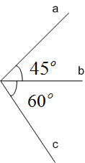
The angle between lines a and c in the figure above measures: _______.
- fifty five degrees
- sixty five degrees
- seventy five degrees
- one hundred and five degrees

Question 3: Which lines are parallel, in the figure below?
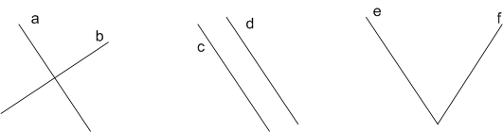
- a and b
- c and d
- e and f

Question 4: In the figure below, the ________________ triangle is a right triangle.
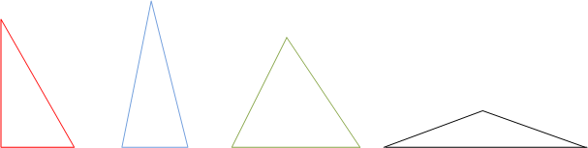

Question 5: Which of the lines a and b are lines of symmetry for the rhombus ABCD?
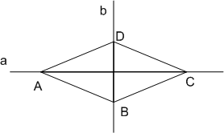
- a
- b
- both a and b
- neither a nor b

Question 6: A two feet piece of tape is 24 times as long as another piece of tape that measures:

- one inch
- one and a half inches
- two inches
- four inches

Question 7: Six minutes are equal to _______seconds.

Question 8: A 2kg laptop computer is ______times heavier than a 500g tablet computer.

Question 9: An electric cable 144 meters long is cut into 24 equal length smaller cables. What is the length of each of the 24 cables?
- 4 meters
- 6 meters
- 8 meters
- 12 meters

Question 10: The length of a rectangular room is 6 meters and the area of the same room is 21 square meters. The width of this room is ________meters.

Question 11: In the figure below, O₁ is the center of circle C, O₂ is the intersection of diagonals of square S and O₃ is the intersection of diagonals of rectangular R.
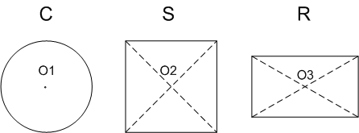
Which of the following statements is true?
- Any line that passes through point O3 is a line of symmetry for rectangle R
- Any line that passes through point O2 is a line of symmetry for square S
- Any line that passes through point O1 is a line of symmetry for circle C

