**TIGER ACADEMY NEW HIRE PROCEDURES**

**INTERVIEW**

Interview Phone Call

Confirm email address

Confirm email with interview date, time, location, and interviewer

Online Employment Application

<http://www.firstcoastymca.org/globals/employment>

Official College Transcript

**NEW HIRE ORIENTATION**

YMCA Pre-hire Orientation Documentations

Teaching Certificate

Duval County School Board - Fingerprint

**NEW EMPLOYEE CHECKLIST**

Complete once cleared to work

**INTERVIEW**

Interview Phone Call

* Confirm email address
* Confirm interview date, time, location, and interviewer

Hi **John Smith**,

I have you scheduled for an interview with Mr. McWhite, *Principal* on **Wednesday June 6th at 2:00p.m.** at Tiger Academy. I have included the address and a map below that will hopefully help you get here smoothly.

**6079 Bagley Road**

**Jacksonville, FL 32209**

**904.309.6840**

Bagley Rd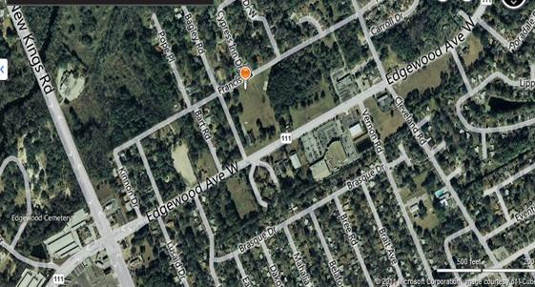

Please let me know if you have any questions.

Thank you,

* Online Employment Application

<http://www.firstcoastymca.org/globals/employment>

* Official College Transcript

**NEW HIRE ORIENTATION**

* YMCA Pre-hire Orientation Documentations

☐        I-9 Form with two supporting original forms of ID (photocopies will not be accepted) - please complete only page 1 of the form

Page 4 of your pre-hire packet attached above will explain the required ID’S that we will accept.

If you do not bring both of your ID’S with you to pre-hire, you will be turned away, and rescheduled for a later date.

☐        Completed Direct Deposit Authorization Form with:

☐        Voided check or letter from the bank to authorize checking account deposit

☐        Letter from the bank to authorize savings account deposit

☐        Completed Affidavit of Good Moral Character

☐        Two (2) letters of employment recommendation, including phone numbers (may be personal or professional)

☐        Redwoods Online Training Courses:

Blood borne Pathogens, Child Sexual Abuse Prevention, Slips, Trips, and Falls, Social Media Training, Hazardous Communications, Sexual Harassment Prevention. Instructions attached to email.

☐        **If applicable to your position**- lifeguard certifications, CPR cards, Group Exercise Certifications, etc.

**The packet will be explained in its entirety at Pre-hire Orientation and all questions will be answered.**

**If you do not know how to fill out a form- HR will help you at Pre-Hire Orientation.**

* **Online Training required prior to attending Orientation. Please Note: Will take 4-6 hours to complete.**
* The YMCA is committed to providing a safe environment for everyone we serve.  As part of the hiring process, 6 online training courses are required to be completed before Pre-hire Orientation. You must print and bring your certificates of completion with you.
* The 6 courses you are required to take are **Blood Bourne Pathogens, Social Media, Child Sexual Abuse Prevention, Hazardous Communications, Sexual Harassment Prevention and Slips, Trips, and Falls.**
* Please note- Slips, Trips, and Falls will not appear in the course list.  Please use the search field to locate and register for this course.
* Teaching Certificate
* Duval County School Board - Fingerprint

**NEW EMPLOYEE CHECKLIST**

Complete once cleared to work