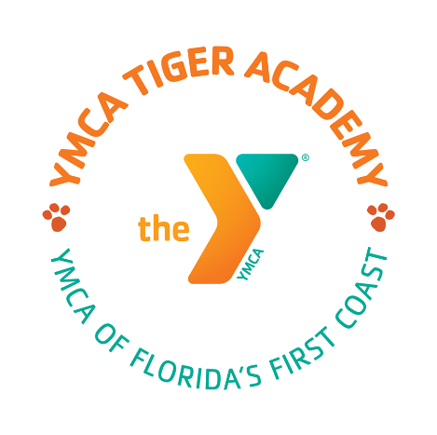
Tiger Academy Board of Directors Public Notice
Tuesday, April 2, 2024

Governance Committee Meeting
10:00 A.M. – 10:30 A.M.

Finance Committee Meeting
10:30 A.M. - 11:00 A.M.

Board Meeting
11:00 A.M. – 1:00 P.M.

Tiger Academy
Media Center
6079 Bagley Road
Jacksonville, Florida 32209

Lauren Gibbs
904-553-0839
lgibbs@fcymca.org

