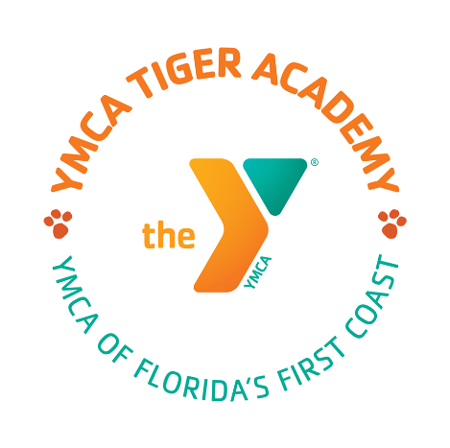
Tiger Academy Board of Directors Public Notice

Tuesday, October 24, 2023

12:00 P.M.
Curriculum Committee Meeting

Bonos BBQ
10645-200 Philips Hwy.
Jacksonville, FL 32256

Lauren Gibbs
904-553-0839
lgibbs@fcymca.org

