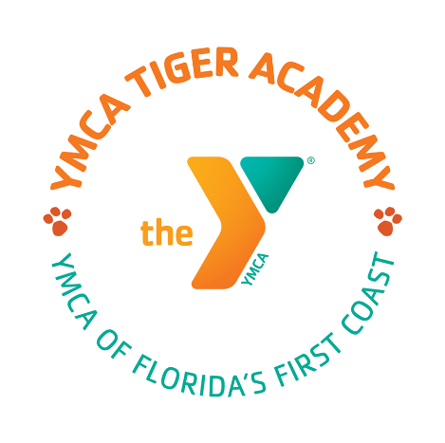
Tiger Academy Board of Directors Public Notice

Monday, September 26, 2022

Board Retreat
11:00 A.M. – 2:00 P.M.

Jessie Ball DuPont Building
40 East Adams St.
Jacksonville, FL 32202
Board Room #318/Floor 3

*visitor parking is available in spaces #15-20 in the YMCA visitor parking lot across the street from the DuPont Center. There is plenty of parking around the building and can be reimbursed if it is paid parking.

*If you are unable to attend in person you may contact Lauren Gibbs for a Zoom link to join the meeting.

Lauren Gibbs
904-553-0839
lgibbs@fcymca.org

